Analysis and Visualization
This chapter introduces the Web Audio API's AnalyserNode. It is somewhat unique amongst nodes in that it can be used as a destination or an intermediate node. It does not modify the incoming audio, but instead provides data about the stream that is useful for analysis, visualization or metering purposes. This data can be in either time or frequency domain. Here, we again provide some Fourier theory so that one can understand how the frequency domain data is acquired and represented. An example is given for visualizing the data returned by the AnalyserNode.

AnalyserNode
So far we’ve only talked about audio synthesis and audio processing, but the Web Audio API also provides audio analysis. The main example use of this feature is visualization, but there are many other applications, including pitch and beat detection, and speech recognition. This is also an important topic since a good visual analyzer can act as a debugging tool (in addition to your ears) for tweaking sounds to be just right.
Most signal analysers use some form of Fourier analysis to represent signals in the frequency domain. Fourier theory is incredibly useful for working with signals and their frequency content, and encompasses much more than the Fourier series that we saw previously. We don’t go into depth about it here, but introduce a few key concepts needed to understand analysis and visualization in the Web Audio API.
The main approach to doing sound analysis with the Web Audio API is to use an AnalyserNode. It provides two ways for you to inspect the input audio stream, in time or frequency domain. The node can be placed anywhere in your audio graph, and it does not change the sound in any way. The audio stream will be passed un-processed from input to output, so it can be treated as an intermediate node, with its output connected to other nodes, or as a destination with no further connections.
To find the current time domain data for analysis, the input signal is down-mixed as if channelCount is 1, channelCountMode is 'max' and channelInterpretation is 'speakers'. This is independent of the settings for the AnalyserNode itself. That is, it will always down-mix to mono, and will use mixing rules to do so if possible. This downmixing however, is just for internal use; any node connected to the output of an AnalyserNode will see the same stream that was used as the input to the AnalyserNode.
For frequency domain analysis, a Fast Fourier Transform (FFT) is performed on this time domain data.
The node has four optional parameters to customize the output of the node:
- fftSize defines both the buffer size of the FFT used to perform analysis in the frequency domain, and the buffer size used for time domain analysis. It must be a power of two between 32 (2⁵) and 32768 (2¹⁵), with default value 2048 (2¹¹). Higher values will result in more fine-grained analysis of the signal, at the cost of some performance loss.
The next three parameters are only relevant for frequency domain analysis.
- minDecibels (default -100) defines the minimum power in dB for a frequency bin.
- maxDecibels (default -30) defines the maximum power in dB for a frequency bin
- smoothingTimeConstant is a value between zero and one, with default 0.8. It's an exponential average between the current buffer and the last buffer the AnalyserNode processed, and results in a much smoother set of value changes over time. A high value results in highly smoothed, slowly changing results. A value of zero means no smoothing is applied, so that the frequency domain data is just a snapshot of the frequency content in a signal in a given window of time.
It also has one read-only property.
- frequencyBinCount: set to fftSize/2. This is the size of the frequency data that results. This is not strictly needed as an exposed property. But one has twice as much time domain data to work with as frequency domain data, so having frequencyBinCount as a separate property is convenient to keep track of this.
Furthermore, it has the following four methods.
- getFloatTimeDomainData(array) copies the down-mixed time domain data into an array of length fftSize.
- getByteTimeDomainData(array) copies the time domain data to an array of 8 bit unsigned integers (0 to 255), of size fftSize. For time domain data x[k], the byte value is b[k]=⌊128(1+x[k])⌋. b[k] is clipped to the range 0 to 255.
- getFloatFrequencyData(array) copies the frequency data, in decibels, into an array of length frequencyBinCount.
- getByteFrequencyData(array) copies the frequency data to an array of 8 bit unsigned integers (0 to 255), of size frequencyBinCount. If Y[k] is the windowed and smoothed frequency data, then the byte value is b[k]=⌊255$\frac{Y[k]-{dB}_{min}}{{dB}_{max}-{dB}_{min}}$⌋, where ⌊ ⌋ represents rounding down, dB_{min} is minDecibels, dB_{max} is maxDecibels, and b[k] is clipped to the range 0 to 255.

FFT Windowing and Smoothing over Time
The following steps are performed to compute the frequency data.
First, a Blackman window is applied to the time domain input data, x[n], where n=0,…,N−1 and N is fftSize. The windowed signal is $\hat{x}\left[n\right]=x\left[n\right]w\left[n\right]$ where
$$w\left[n\right]=0.42-0.5\cos{\frac{2πn}{N}}+0.08\cos{\frac{4πn}{N}},\text{ for }n=0,…,N-1$$
Next, the Fast Fourier Transform (FFT) is applied to the windowed time domain input data to get complex frequency data.
$$X\left[k\right]=\frac{1}{N}\sum_{n=0}^{N-1}{\hat{x}\left[n\right]} W_{N}^{-kn}$$
for k=0,…,N/2−1 where W_{N}=e^{j2π/N}. For those not familiar with Fourier analysis, this essentially represents the original time domain data as a sum of sinusoids, where each one has a frequency that is a multiple of the fundamental frequency, determined by the duration of the data, and X[k] represents how much of the k^{th} sine wave is in the original signal.
This frequency domain data is then smoothed, using
$$X'[k]=τX_{-1}^{'}\left[k\right]-(1-τ)|X[k]|,$$
where $|X[k]|$ are the magnitudes of the complex Fourier transform values, $X_{-1}^{'}\left[k\right]$ is the smoothed value from the previous block (set to 0 if this is the first block), and τ is the smoothingTimeConstant.
Finally, we convert to decibels using:
$Y[k]=20\log_{10}X'[k]$].
This array of values Y[k] is the output for getFloatFrequencyData(). For getByteFrequencyData(), Y[k] is clipped to lie between minDecibels and maxDecibels and then scaled to fit in an unsigned byte such that minDecibels is represented by 0 and maxDecibels represented by 255.
Due to the smoothing and windowing, we are not getting exact values of the magnitude spectrum. But using exact values can be problematic for visualization and analysis; FFT values can ‘jump around’ from frame to frame, and spectral leakage means that problematic frequencies can sometimes be obscured by content leaking from other frequency bins. Rather than producing an exact magnitude spectrum at a specific time, the frequency data produced by the AnalyserNode represent useful information for identifying the nature of the frequencies represented in the signal as they evolve over time.

Using the AnalyserNode
The analyser node can be used as an additional destination, with no output. Or it can be inserted between two connected nodes, in which case it passes the input to the output unchanged and without latency. So the following two statements are equivalent.
firstNode.connect(analysisNode).connect(nextNode);
And
firstNode.connect(analysisNode);
firstNode.connect(nextNode);
Once we define arrays to hold the time or frequency domain data, such as,
var freqData = new Float32Array(analysisNode.frequencyBinCount);
then we can get the relevant data at any time by calling methods for the analyserNode’s methods, such as
analysisNode.getFloatFrequencyData(Magnitudes);
Here, Magnitudes is an array of 32-bit floats corresponding to the magnitudes of each frequency bin. The indices of the output can be mapped linearly between 0 and the nyquist frequency, which is defined to be half of the sampling rate. So in this example Magnitudes[n] represents the strength of the content around the frequency n·f_{s} / N, where f_{s} is the sampling frequency and N is the FFT size. Similarly, content at frequency value f resides in the bin with array index ⌊ N · f / f_{s} ⌉, where ⌊ ⌉ represents rounding to the nearest integer.
The frequency domain is also available in 8-bit unsigned units via the getByteFrequencyData call. The values of these integers is scaled to fit between minDecibels and maxDecibels (in dBFS) properties on the analyzer node, so these parameters can be tweaked to scale the output as desired.

Example - Visualizing Sound
Putting it all together, we can set up a render loop that queries and renders the analyzer for its current frequency or time-domain analysis, Code example 7.1.

<canvas id='canvas' width='512' height='256' ></canvas><br>
<button onclick='audioContext.resume()'>Start</button>
<input type='checkbox' id='Spectrum'>Spectrum<br>
<input type='range' max=4000 value=440 id='Frequency'>Frequency
<script src='Analyser.js'></script>

let canvasContext= canvas.getContext('2d')
let audioContext= new AudioContext()
let source= new OscillatorNode(audioContext,{type:'square'})
let analyser= audioContext.createAnalyser()
source.connect(analyser)
source.start()
var data = new Uint8Array(analyser.frequencyBinCount)
Frequency.oninput = function() { source.frequency.value = this.value}
draw()
function draw() {
let height=canvas.height, width=canvas.width
if (Spectrum.checked) analyser.getByteFrequencyData(data)
else analyser.getByteTimeDomainData(data)
canvasContext.clearRect(0,0,canvas.width,canvas.height)
for (let i = 0; i < data.length; i++) {
if (!Spectrum.checked) canvasContext.fillRect(i,height*(1-data[i]/256)-1,1,1)
else canvasContext.fillRect(i,height*(1-data[i]/256),1,height*data[i]/256)
}
requestAnimationFrame(draw)
}

Code example 7.1. Analyser.html and Analyser.js, showing example use of the AnalyserNode
This code plots either time-domain or frequency-domain values using an HTML5 canvas, creating a simple visualizer that renders a graph of the waveform or magnitude spectrum. We generate a periodic waveform consisting of a square wave (initially set to 440 Hz) and its first 8 harmonics. The result is a canvas output that looks like Figure 7.1, and changes with time.
Here, we have two contexts, one is the usual AudioContext, the other is a drawing context for the HTML Canvas element. requestAnimationFrame tells the browser to update the animation using the draw function. It does this by getting new time or frequency domain data and drawing that in the canvas.
To visualize our signal, we use a requestAnimationFrame to periodically query the analyzer, process the results, and render them. This API lets the browser incorporate your custom draw function into its native rendering loop. Instead of forcing it to draw at specific intervals and contending with the rest of the things a browser does, you just request it to be placed in the queue, and the browser will get to it as quickly as it can. We use it to query the analyzer node to give us detailed information about the state of the audio stream.
But lets focus on the AnalyserNode and how its used. The source is connected to the analyser. The analyser does not have to be connected to anything, and in this case, we aren’t even producing sound since nothing is connected to the audio context’s destination.
Here, we’re only interested in coarse data for display, so we get time or frequency domain data as bytes. We define the array data to hold this data. Whenever we refresh the animation, we call getByteTimeDomainData or getByteFrequencyData to acquire the latest data for plotting.
Our approach to visualization may miss some data, since we only acquire it at the refresh rate of the browser (typically 60 frames per second, with millisecond precision). For music visualization purposes, that’s fine. If however, we want to perform a comprehensive analysis of the whole audio buffer, we should impose more accurate control over how the data is acquired. Its also useful to remember that multichannel input is downmixed, so one should use a ChannelSplitter (see 0) first if one wants to analyse individual channels.
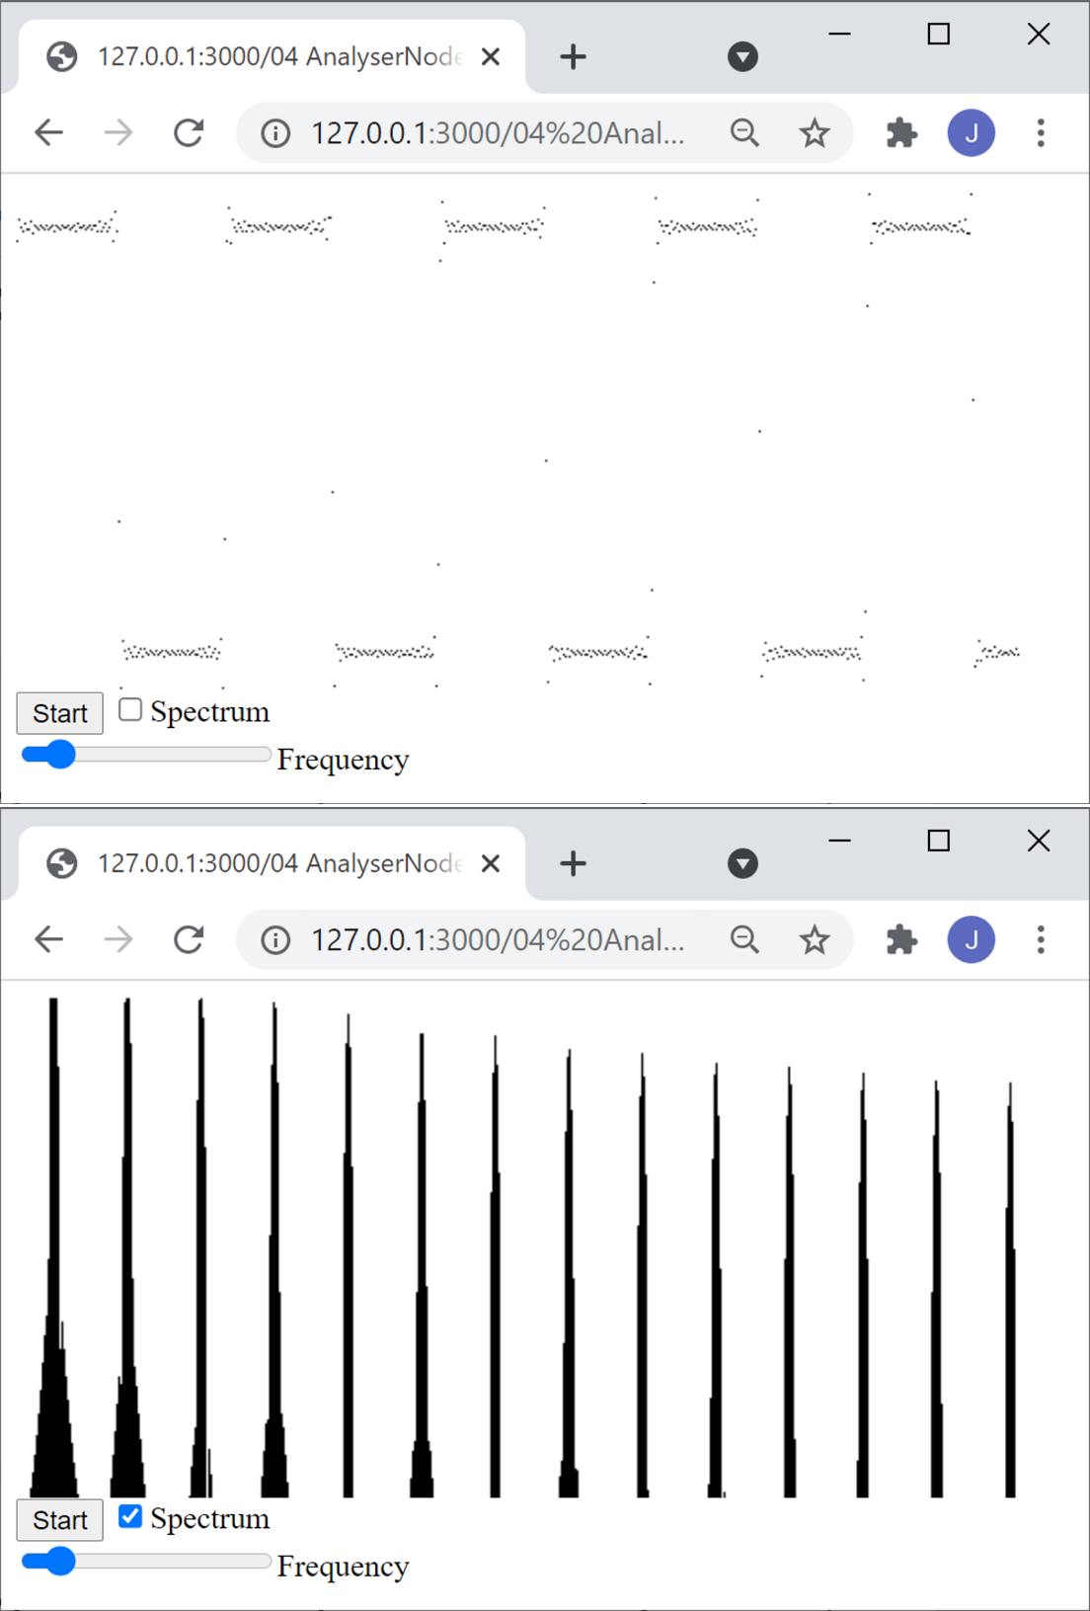
Figure 7.1. The output of Code example 7.1, showing either the time domain waveform (top) from time domain data or magnitude spectrum (bottom) from frequency domain data.

